## horizontal line



PHP PROJECT DEVELOPER GUIDE

Online Movie System

**(Batch: 2010B3)**

19.5.2022

**─**

**PROJECT** **SUBMITTED BY**

|  |  |
| --- | --- |
| Student1278398 | MUHAMMAD IRFAN |
| Student1278149 | MUHAMMAD JUNAID GHANI |
| Student1274232 | HAMZA SIDDIQUI |
| Student1204067 | WAHAJ BIN AHMED |

**Project Instructor Miss Hina Siddiqui**

**Batch Code 2010B3**

# 

SCREEN SHOTS OF SOURCE CODE OF

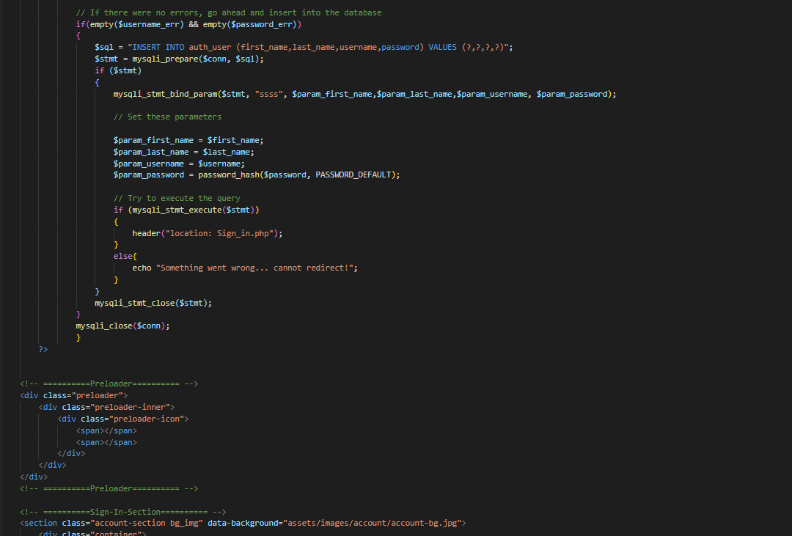Online Movie Booking system

# Home Page:

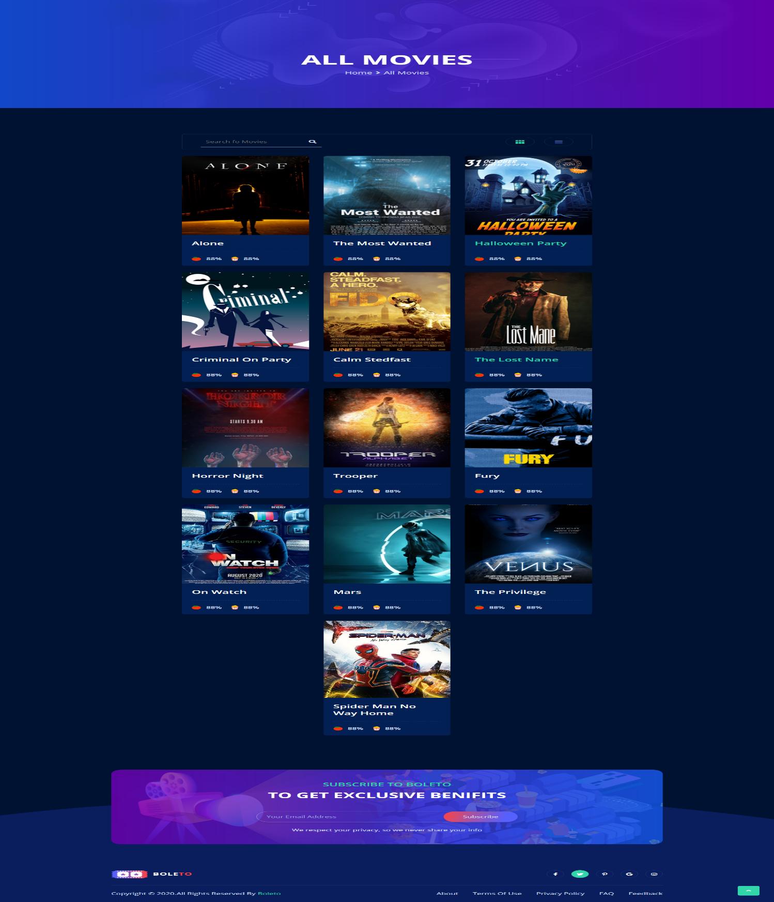

# About Us Page:

# Contact Us Page:

**Admin Panel :**

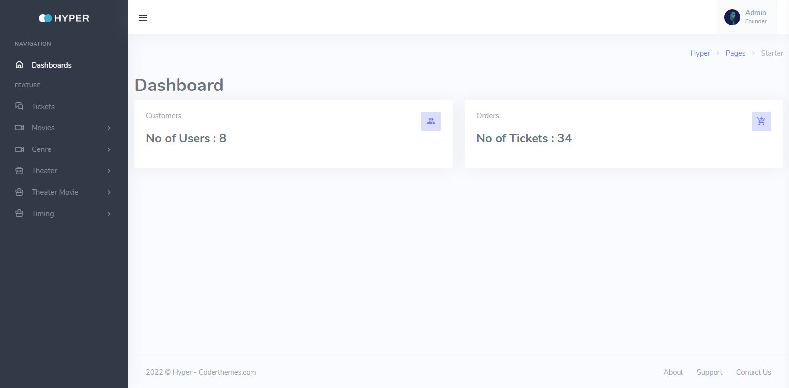

# Signup Page:



# Login Page:

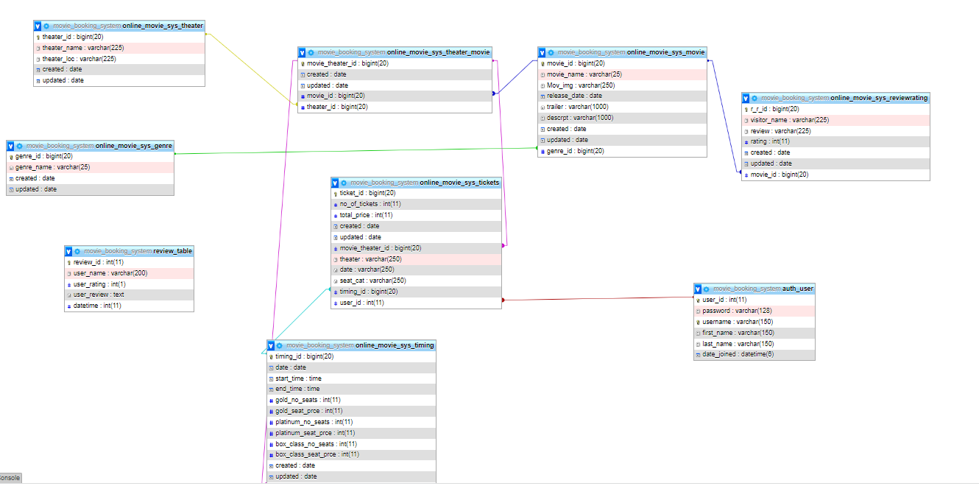Database of PHP Project:

# THE END ….